GETTING MORE DONE™, Efficiently! GETTING MORE DONE™, Efficiently! GETTING MORE DONE™, Efficiently!

SPECIFICATIONS: LCT600

Trailer
- Heavy duty fully height adjustable w/3 quick release pins
- Pintle Eye
- 12” increment adjustable tow bar
- Single Torflex axle - 6,000 LBS
- Electric brakes w/break away actuator
- Top access battery compartment
- DOT LED lighting
- Amber LED strobe lights
Tires
- (2) ST225-75R15 radial tires on steel wheels
- Top wind folding jack with swivel caster
Auxiliary engine
- Kubota 3.8L 87HP Gas (Standard)
- 74 HP John Deere Tier 4 – (Option)
- ECO-MODE Patented system controls which reduces fuel (35%), noise (50%), dust (40%), & wear
- Radiator air screen Pleated and boxed protective, with tool free access
- Electronic controls with safety shutdown
- Instrument panel with display
- Keyed ignition switch
- Air filter with pre-cleaner
- Easy access panels
- Fuel tank 44 Gallon polyethylene
Engine/Vacuum System Skid
- Tab and Slot construction throughout
- All metal laser-cut for precision
Clutch
- PTO engage / disengage
- Automotive style 13”
- 2.25” shaft
- Drives a 4 groove power band
- Belt drive reduces shock and vibration
- Easily adjustable
Boom/Hose
- Single Axis: Nozzle mounted hydraulic controls
- Power-up and flow-controlled gravity down
- 2 and 3-axis available
- Remote control available for 2-3 axis
- Hydraulic powered 12V system
- 16”x120” HD flexible rubber vacuum hose
- Urethane vacuum hose option
- Steel nozzle

SPECIFICATIONS: LCT600 (continued)

Exhaust Hose
- 45-degree exhaust duct
- 16” x 48” HD rubber exhaust hose
Fan / Impeller
- 28” fan standard - 30% Compaction
- Option: 30” Fan - 25% Compaction
- Option: Shred Master™ Fan – 40% Compaction
- Self-clearing
- Scalloped design reduces decibel level
- Back plate protects bearings and shaft
- Fans are robotically welded, harmonically annealed and statically and dynamically balanced
- AR400 material
Fan Bearings
- Proprietary Quad-Glide™ sealed bearings
- Designed in partnership with Timken engineering
- Grease zerks located outside housing with high pressure feed lines
Fan housing
- Cleanout door is safety interlocked
- Replaceable ¼” steel liners
- Robotically welded

VALUE-ADDED HIGHLIGHTS

Walkaround Outline for the
ODB LCT600
ODB’s Most Popular
Tow-Behind Leaf Loader

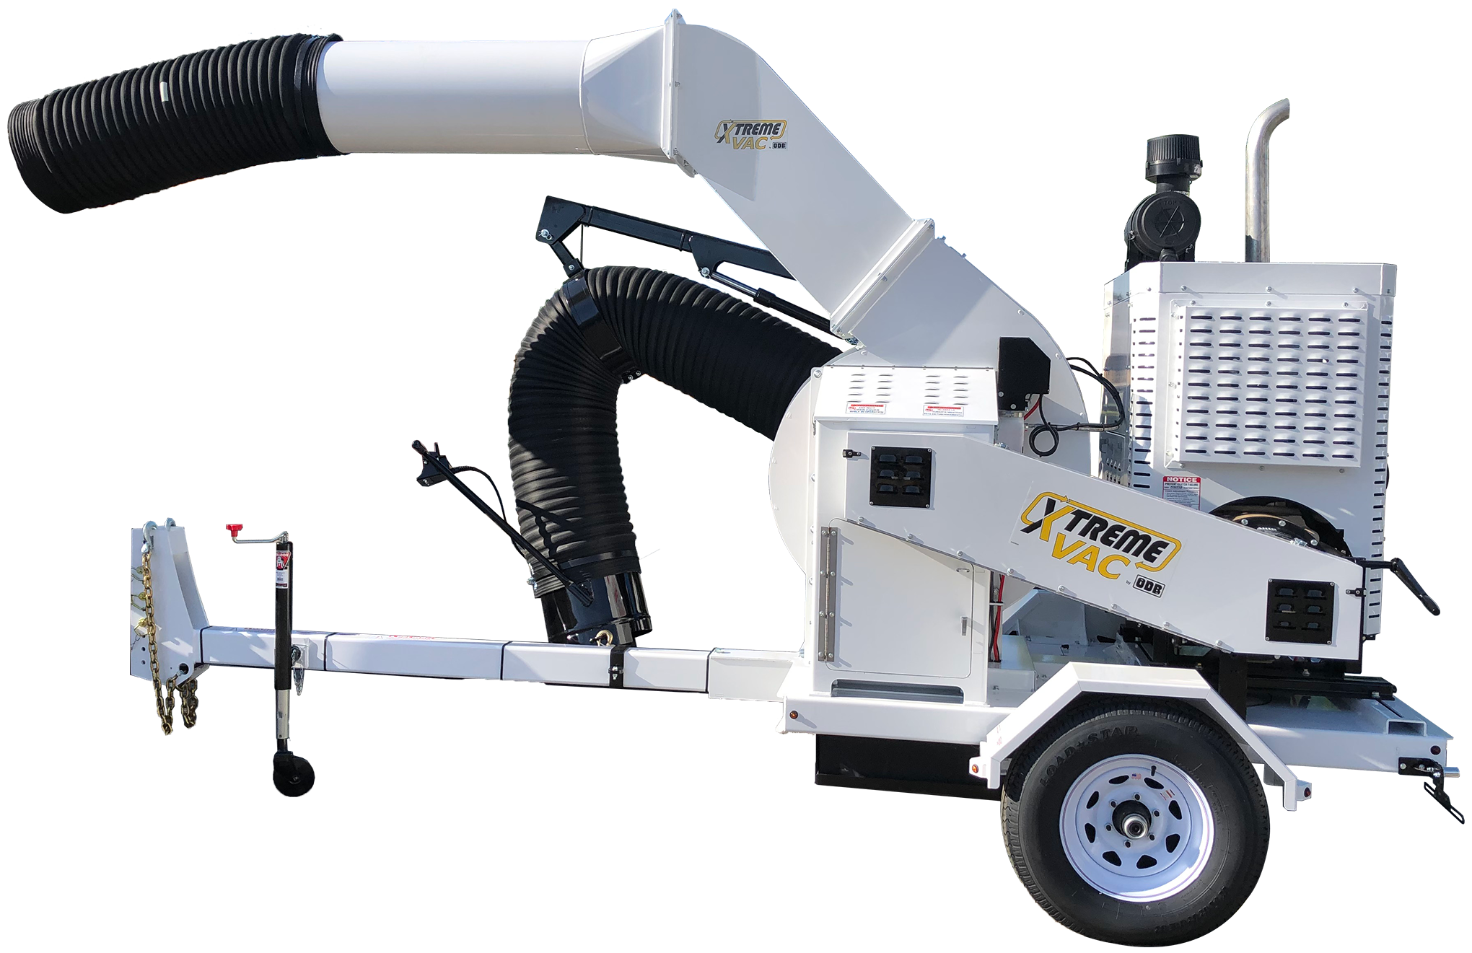

  - Intake Hose Positioned in Front of Axle
  - Better visibility by the driver of the vacuum operator
  - Safer Operation
  - Lightweight
  - Maneuverability in Tight Spots
  - ODB Operator-Centric Engineering
  - Safer & Easier for the Operator
  - Simple Maintainability
  - Available w/2 or 3-Axis and Remote-Control Option
  - Less Operator Fatigue
  - Faster Collection with Less Operators
  - ODB Proven Build Quality
  - More Reliable, Long Operational Life

ODB Company 5118 Glen Alden Drive Richmond, VA 23231
800.446.9823 www.odbco.com
ODB Company 5118 Glen Alden Drive Richmond, VA 23231
800.446.9823 www.odbco.com
ODB Company 5118 Glen Alden Drive Richmond, VA 23231
800.446.9823 www.odbco.com

