LCT450

FEATURES
- Kubota 4-cylinder 87HP gasoline engine.
- Belt Drive, 3-groove power band
- 28 inch diameter impeller made of T-1 steel
- Complete instrument panel
- Rear pickup for vacuuming on both sides of the unit

QUICK SPECS
LCT450/was LCT65 | Xtreme Vac LCT450
Engine | Kubota 4-cylinder 87HP gasoline engine.
Impeller | 28″ diameter with 6 blades
Blower Housing | Constructed of 11 gauge steel with 1/4″ thick steel liners
Suction Inlet | Rear, vacuum on either side of unit
Drive Type | 3-groove power band.

DETAILED SPECS
Section | Detailed Specification
Engine | Kubota WSG3800 3.8L, 4-cylinder gasoline engine rated 87HP @ 2600 rpm.
Air Cleaner | Dry element with pre-cleaner.
Radiator | Pressurized, heavy duty. Trash style with 6-blade fan.
Radiator Screen | Boxed perforated steel screen is bottom hinged to allow for cleaning without powering down the engine. Face of screen is corrugated for maximum surface area and air flow.
Engine Controls | Engine monitoring and controls are housed in a compact, powerful display system. There is a full display which shows engine temperature, RPM, oil pressure, battery volts, fuel level and engine hours. Full throttle control and fault code displays are also included
Engine Sheet Metal | Engine is covered by a custom sheet metal enclosure constructed of 16-gauge steel. The enclosure has front and rear access doors, which are louvered for proper air circulation. Two doors are provided on top of the enclosure for convenient access to the radiator cap and oil fill cap.
PTO | Heavy duty 13” automotive style PTO with a 2.25” shaft.
Drive Type | 3-groove power band.
Trailer Bed | One-piece construction, 1/4″ formed steel plate. 48” wide x 66” long.
Axle | Torflex axle rated at 6,000 pounds with EZ lube hubs and electric brakes.
Tires | ST225-75R15 radial tires mounted on steel rims.
Pintle Hook | Heavy-duty pintle eye that is height adjustable without the use of tools.
Tow Tongue | 89″ long tongue constructed of 4″ square steel tubing.
Parking Jack | Heavy duty top wind jack with steel wheel.
Trailer Lighting | LED stop and turn signals with turn signal indicators. LED strobe is mounted in the rear.
Impeller | 28” diameter with 6 gusseted blades constructed of 3/8” thick abrasive resistant T-1 steel with a Brinell hardness exceeding 400. Each blade is gusseted on the back side and welded to a 1/4” thick backing plate. Impeller blades are flat with serrated tips for increased wear. Impeller is secured to the shaft via a taper lock bushing.
Impeller Bearings | Two 2” diameter double roller 4 bolt flange type bearings.
Impeller Shaft | 2” diameter precision machined steel.
Blower Housing | Outer housing is constructed of 3/16” thick welded steel, front and back plates are 10-gauge steel. A safety kill switch shuts down the engine when the hose is disconnected.
Liners | Made of 1/4” steel.
Suction Inlet | Located on the curb side and incorporates quick access via removable rods.
Intake Hose | 16” diameter x 120” long. Heavy duty flexible rubber hose.
Hose Boom | Hydraulically controlled with an electric operated hydraulic pump. Boom pivots in a greaseable tube for effortless movement. Hydraulic cylinder is 1.5” diameter, with a minimum stroke length of 12”.
Boom Controls | 100% waterproof marine-style switch located on the intake hose nozzle.
Intake Nozzle | 16” diameter nozzle with handle constructed of 12-gauge steel.
Exhaust Duct | Constructed of 12-gauge steel and centered directly over the tongue for a balanced unit.
Fuel Tank | 44 gallon capacity constructed of 1/4″ thick polyethylene.
G.V.W. | 4,500 lbs.
Paint | All metal parts are thoroughly cleaned, primed, painted and dried separately. Each part is primed with a rust inhibitor primer and is painted with two coats of automotive quality paint. The parts are then assembled on the unit so that bolts, nuts, cables and grease fittings are not painted. Standard Color is White.
Options | - John Deere 3029T 4-cylinder 74HP diesel engine – FT4  - Driver’s side pickup  - Urethane suction hose in lieu of rubber  - Urethane coated liners for blower housing  - Fluid drive coupler in lieu of standard clutch
©2020 Xtreme Vac by ODB  All Rights Reserved | *Specifications are based on published information at the time of publication. Specifications are subject to change without notice. Not responsible for typographical errors.
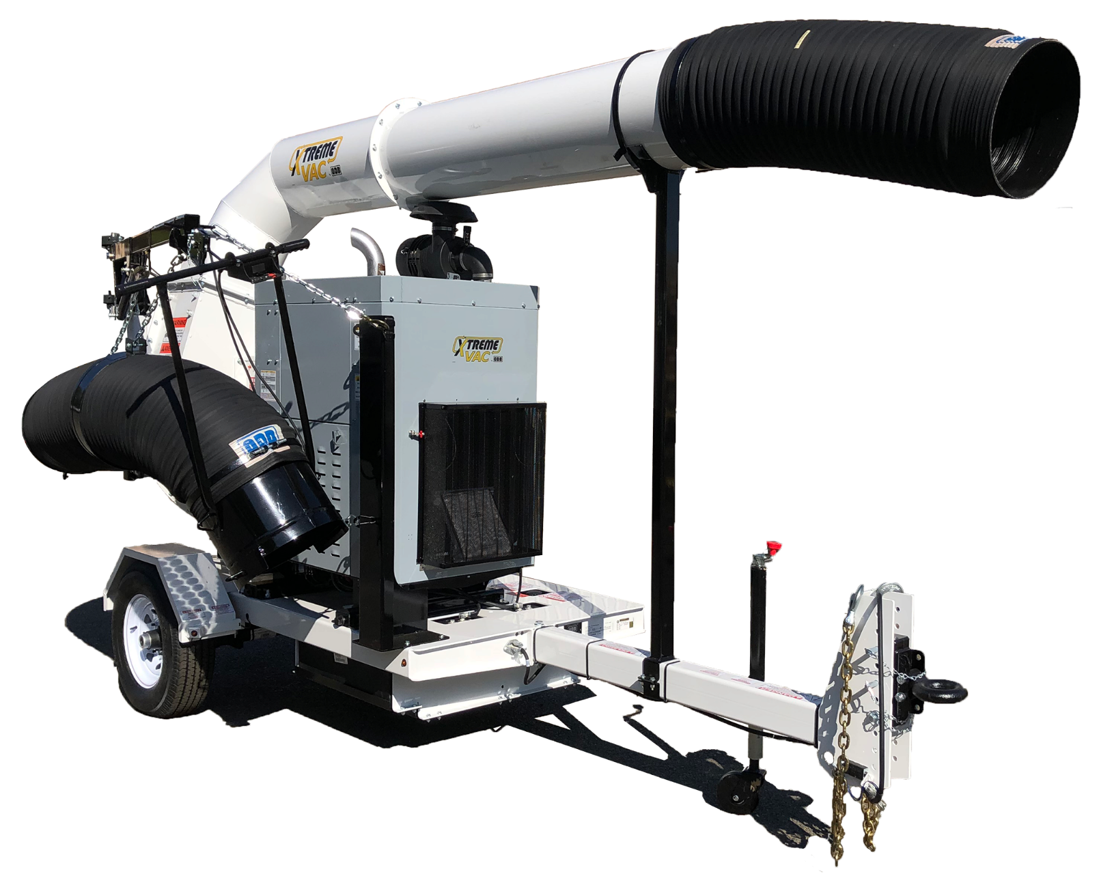
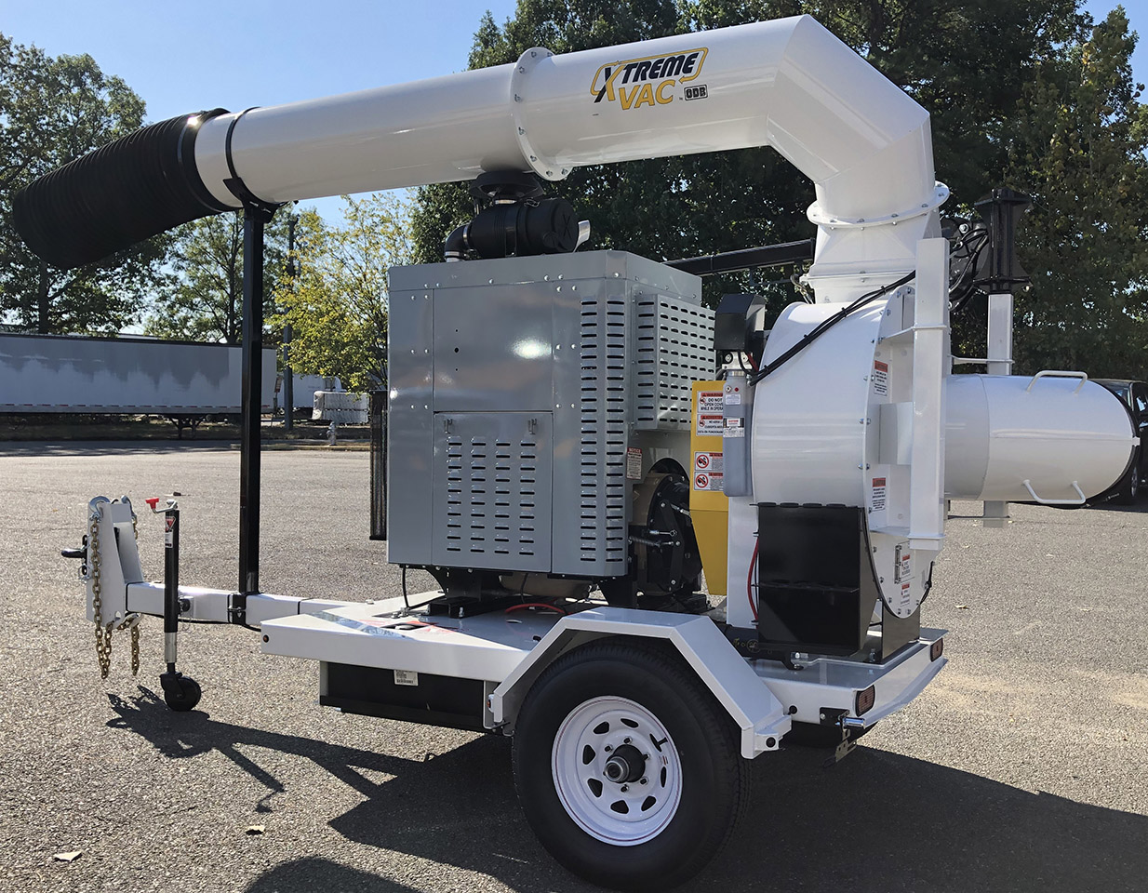
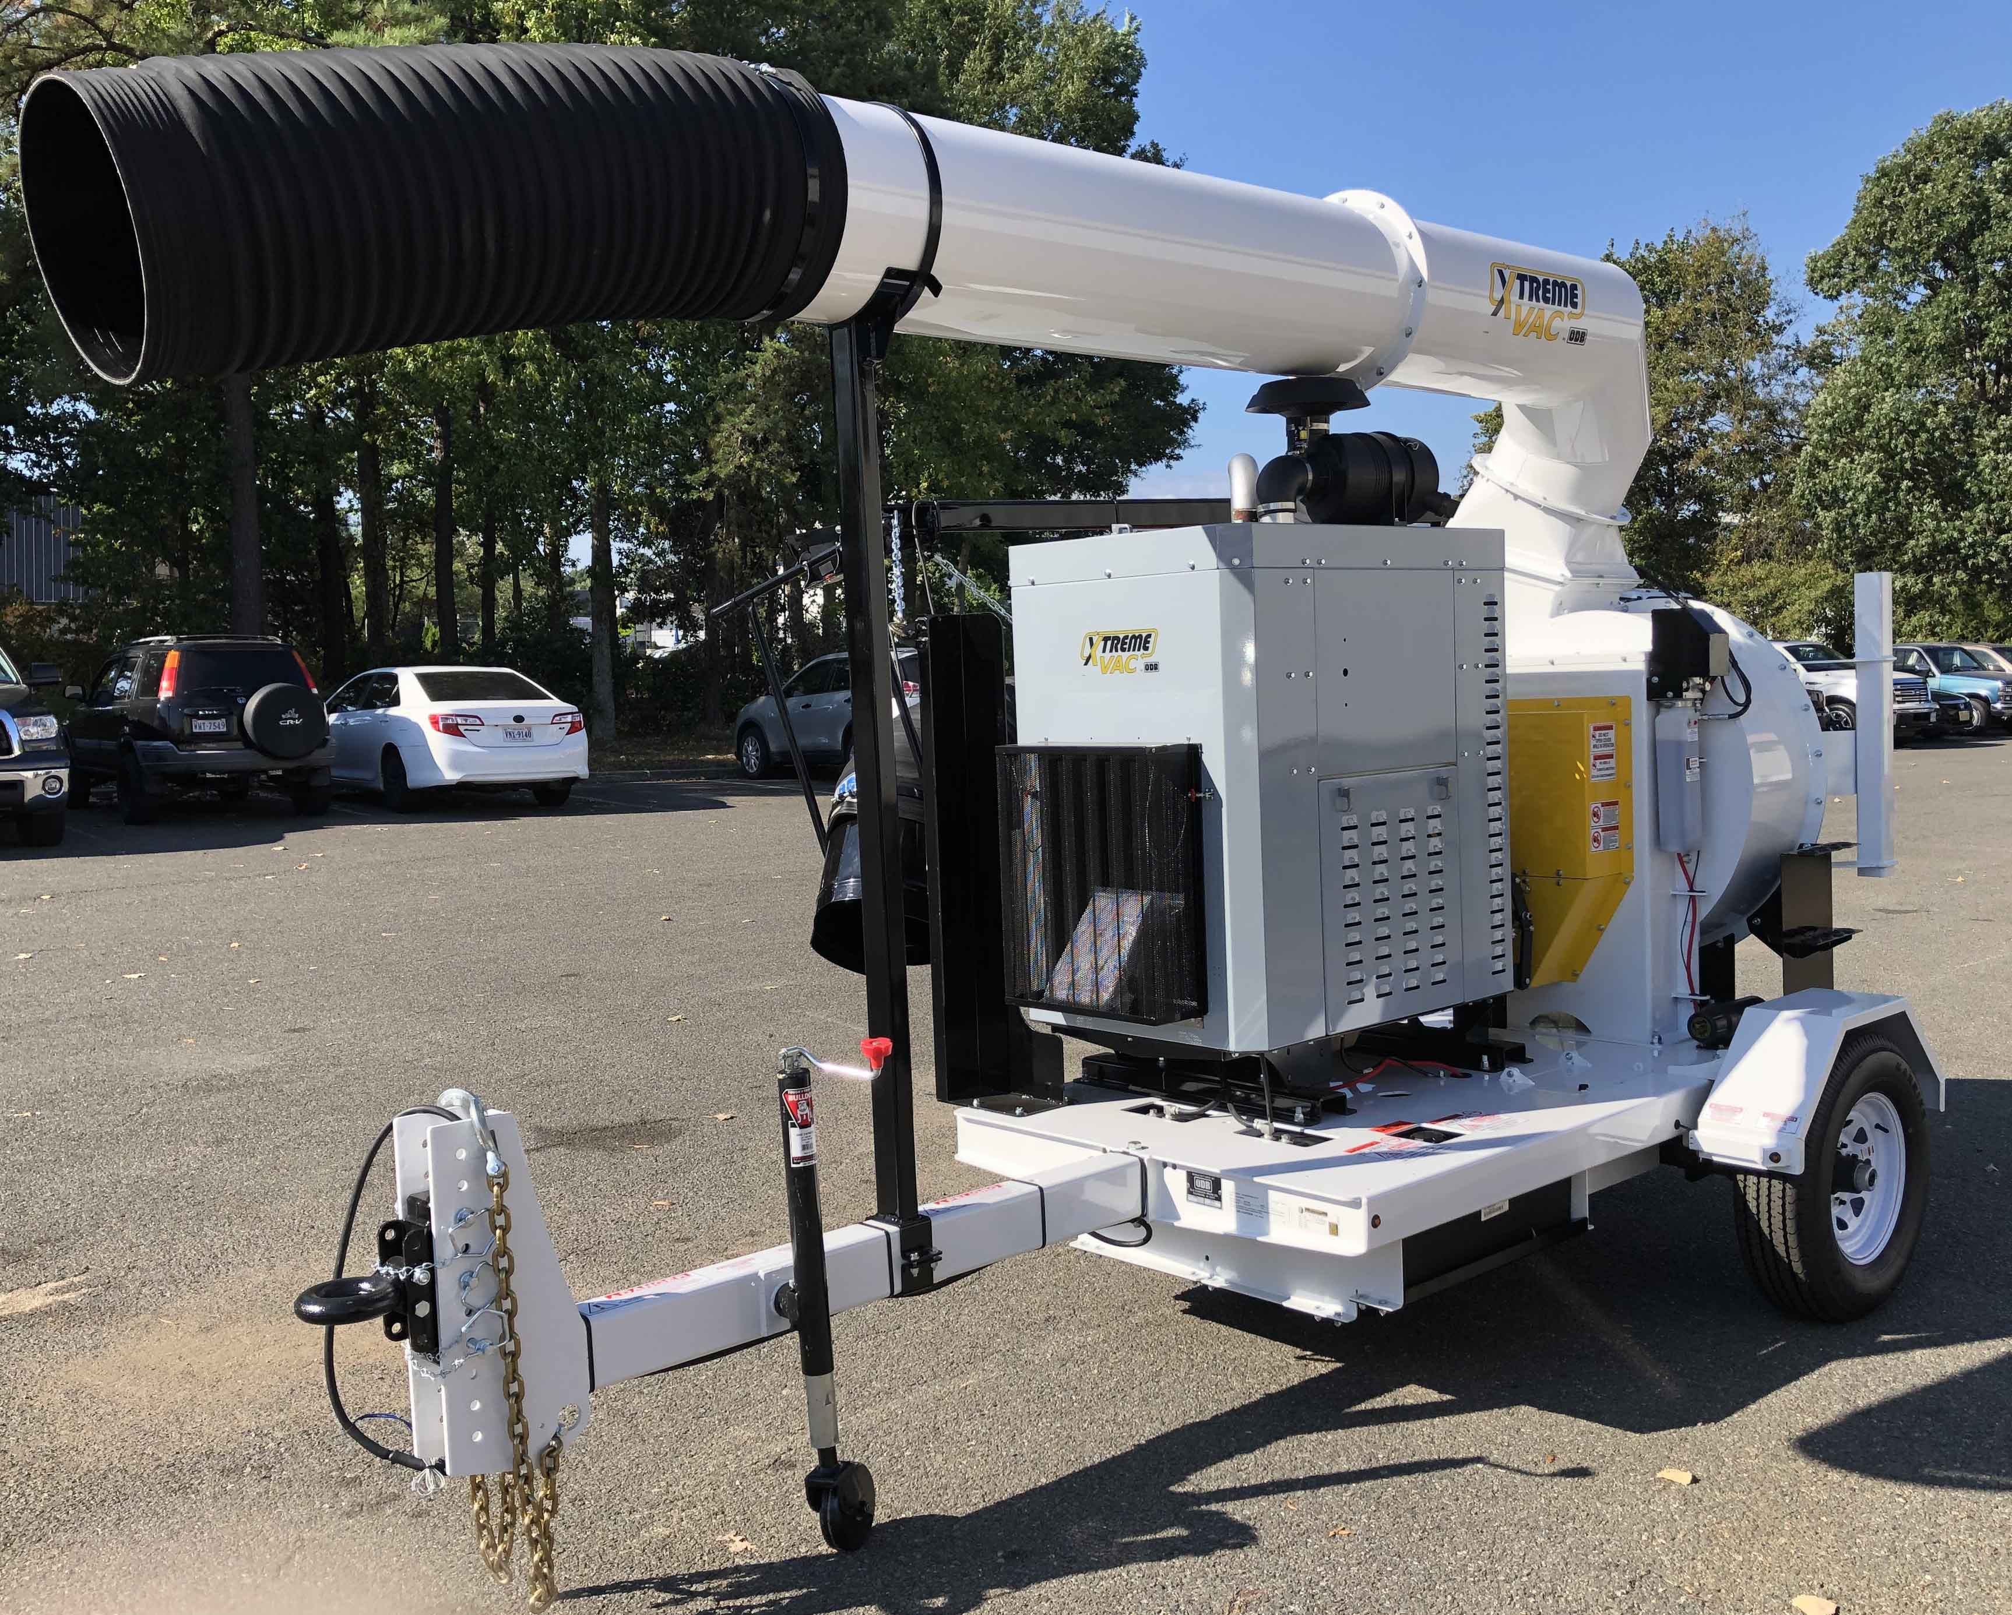
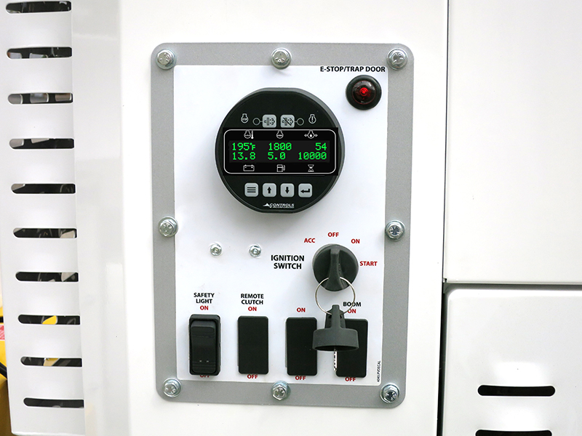
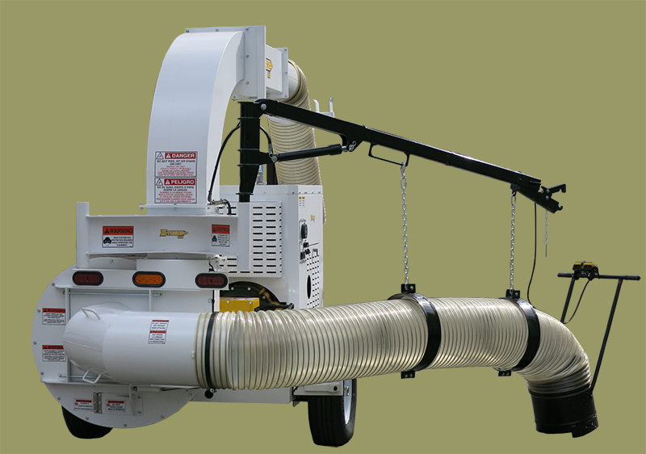
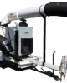
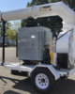
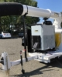
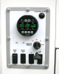
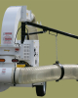

(Units may be shown with optional features and/or colors)
The LCT450 is a powerful, heavy duty debris collector designed for the toughest jobs. The loader uses the powerful Kubota 4-cylinder 87HP gasoline engine to outlast and outperform any debris collector on the market.

